Assignment 2

CS 1083 FR01A

Kisenge Mbaga

PlayList.java

public PlayList addSong(Song songIn){

//TO DO: Complete this method

int newLength = list.length + 1;

Song [] newPlaylist = new Song[newLength];

PlayList finalPlaylist;

long newSong = songIn.getId();

boolean found = true;

int locationCounter=0;

while (found= false){

for (int i=0; i<list.length; i++) {//find placement-see where it fits

Song refSong = list[i];

if (newSong < refSong.getId()){

found =true;

}

locationCounter++;

}

}

for (int i =0; i < newLength; i++){

if (i<=(locationCounter)){

newPlaylist[i]=list[i];

}

if (i==locationCounter+1){

newPlaylist[i]= songIn;

}

if (i>locationCounter+1){

newPlaylist[i]=list[i-1];

}

}

finalPlaylist = new PlayList(newPlaylist);

return finalPlaylist;

}

b.

Input

7

22456321239,Off He Goes ,1

22456321241,Red Mosquito,2

22456321242,Present Tense,2

22456321245,My Poor Brain,2

22456321250,New Way Home,4

22456321255,Lake on Fire,3

22456321261,The Distance,4

6

22456321243,Face and Ghost,2

22456321245,My Poor Brain,2

22456321247,Enough Space,4

22456321249,February Stars,1

22456321250,New Way Home,4

22456321267,Space Travel,5

22456321259,One Hit Wonder,2

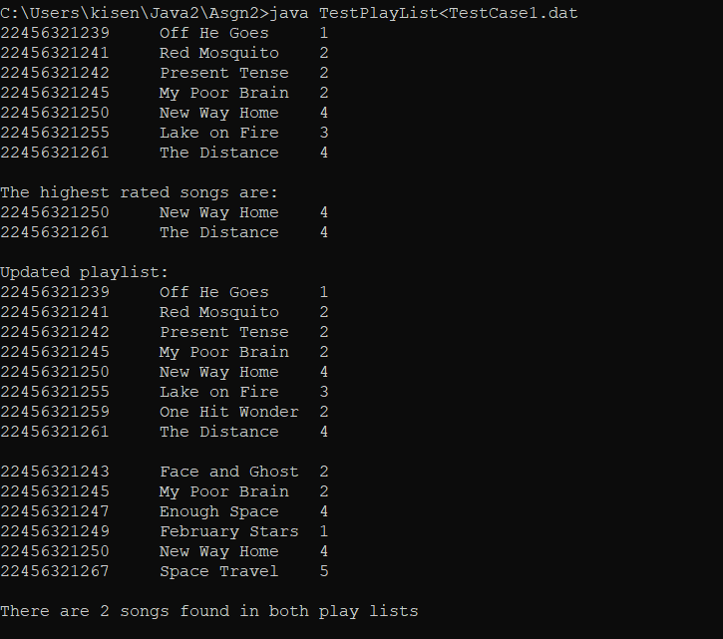Output

Testing

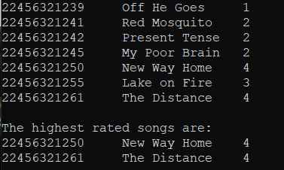

In this case there were two songs with the highest rated value of 4. A new playlist was returned with both of them.

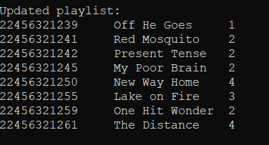



In this case the song One Hit Wonder was added to the playlist in the correct location.

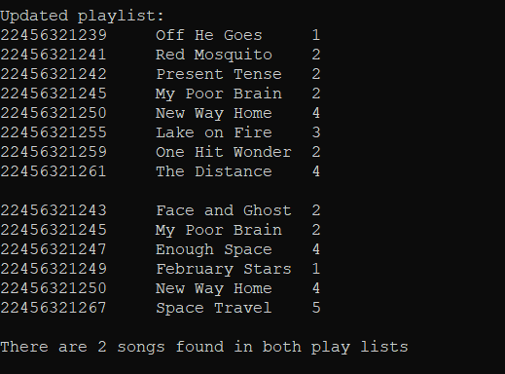

In this case New Way Home and My Poor Brain were found in both playlists.

